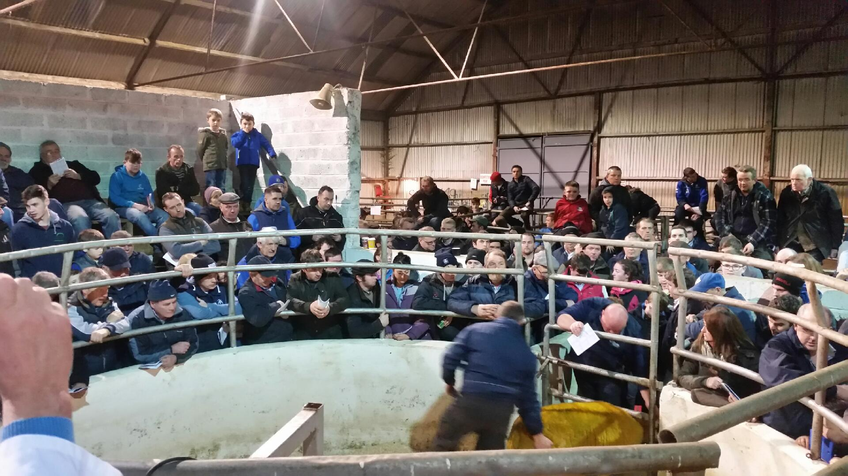

Packed ringside at the Cootehill Texel Twilight Sale.