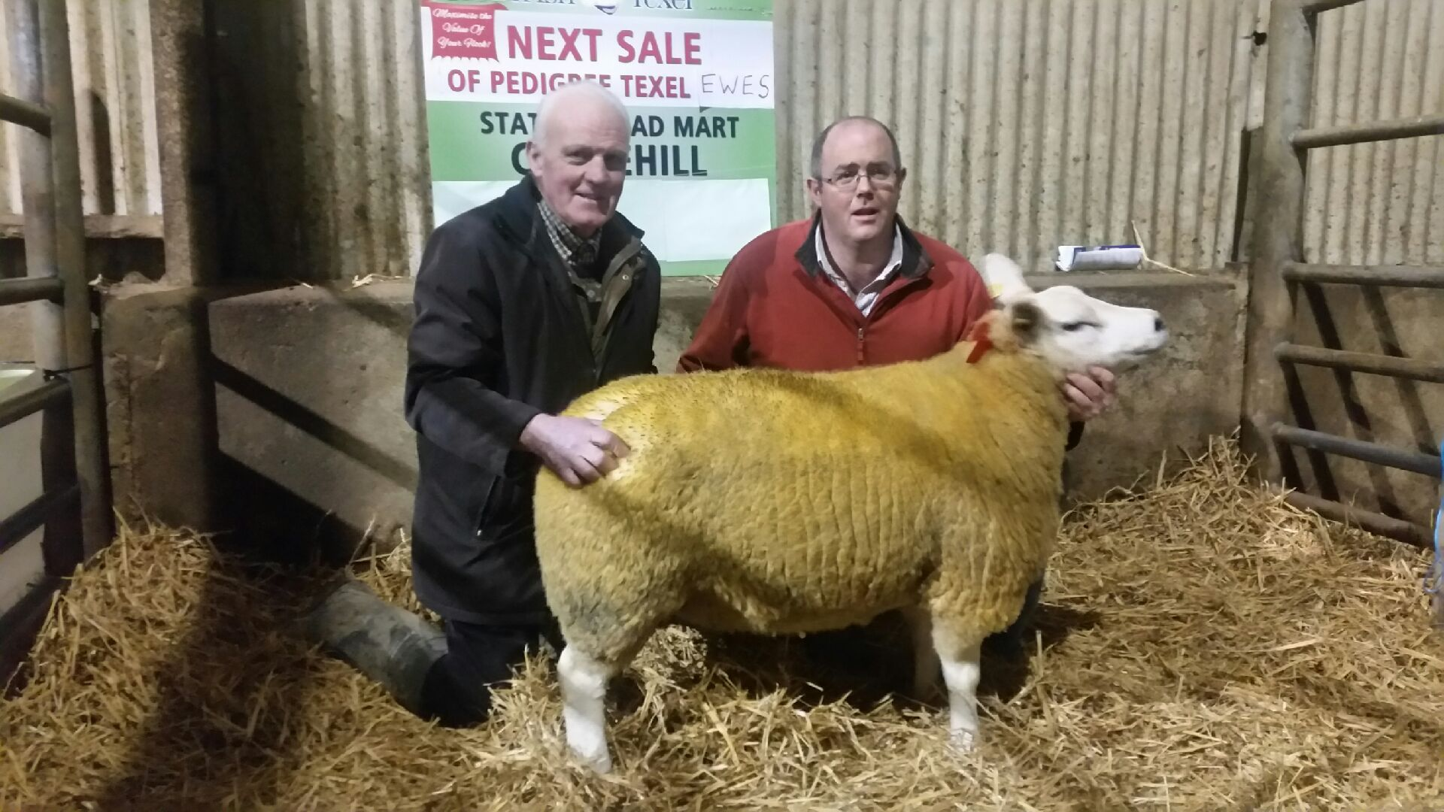

(L – R) John Byrne brother of William Byrne Dublin, purchaser and John Canty Owner. Lot 30 sold for €880,proceeds in aid of The Irish Cancer Society.