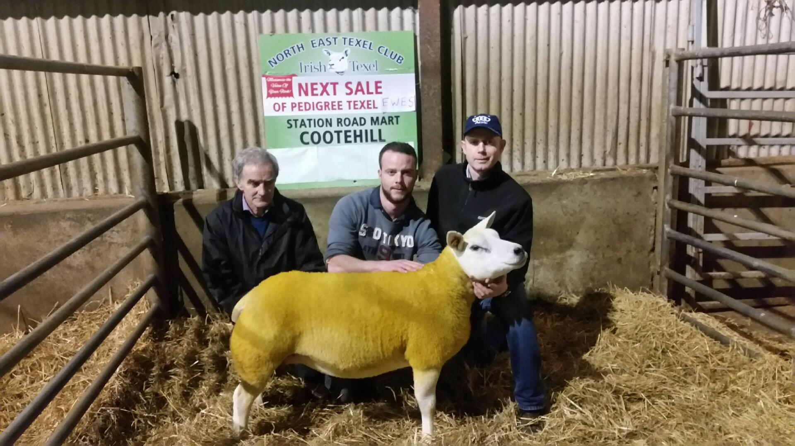

(L –R) Pat Farrell, Barry Farrell Oberstown Texels and Jimmy Reilly, Station Road Mart Cootehill with the top priced sheep of the sale. Lot 9 sold for €2130.